# PROJECT SYNOPSIS

* PROJECT TITLE:

HOME INVIOLABILITY

AIM:

To build an inexpensive home security device for industrial and residential purpose using node MCU

PROJECT DESCRIPTION:

When some Intruder tries to get into your house in your absence, PIR sensor detect the motion of the intruders through his/her body heat & Immediately it sends alarming signal to MCU that some motion has been detected.

Now, through the MQTT protocol the node MCU publishes the message in ADAFRUIT server. happens every time a new message gets published when a motion is detected at the door every time when adafruit server gets a new message, the IFTTT services gets Triggered and the message is send to a user's mobile device saying there is a Intruder at restricted place and you can take necessary action.

TECHNICAL APPROACH:

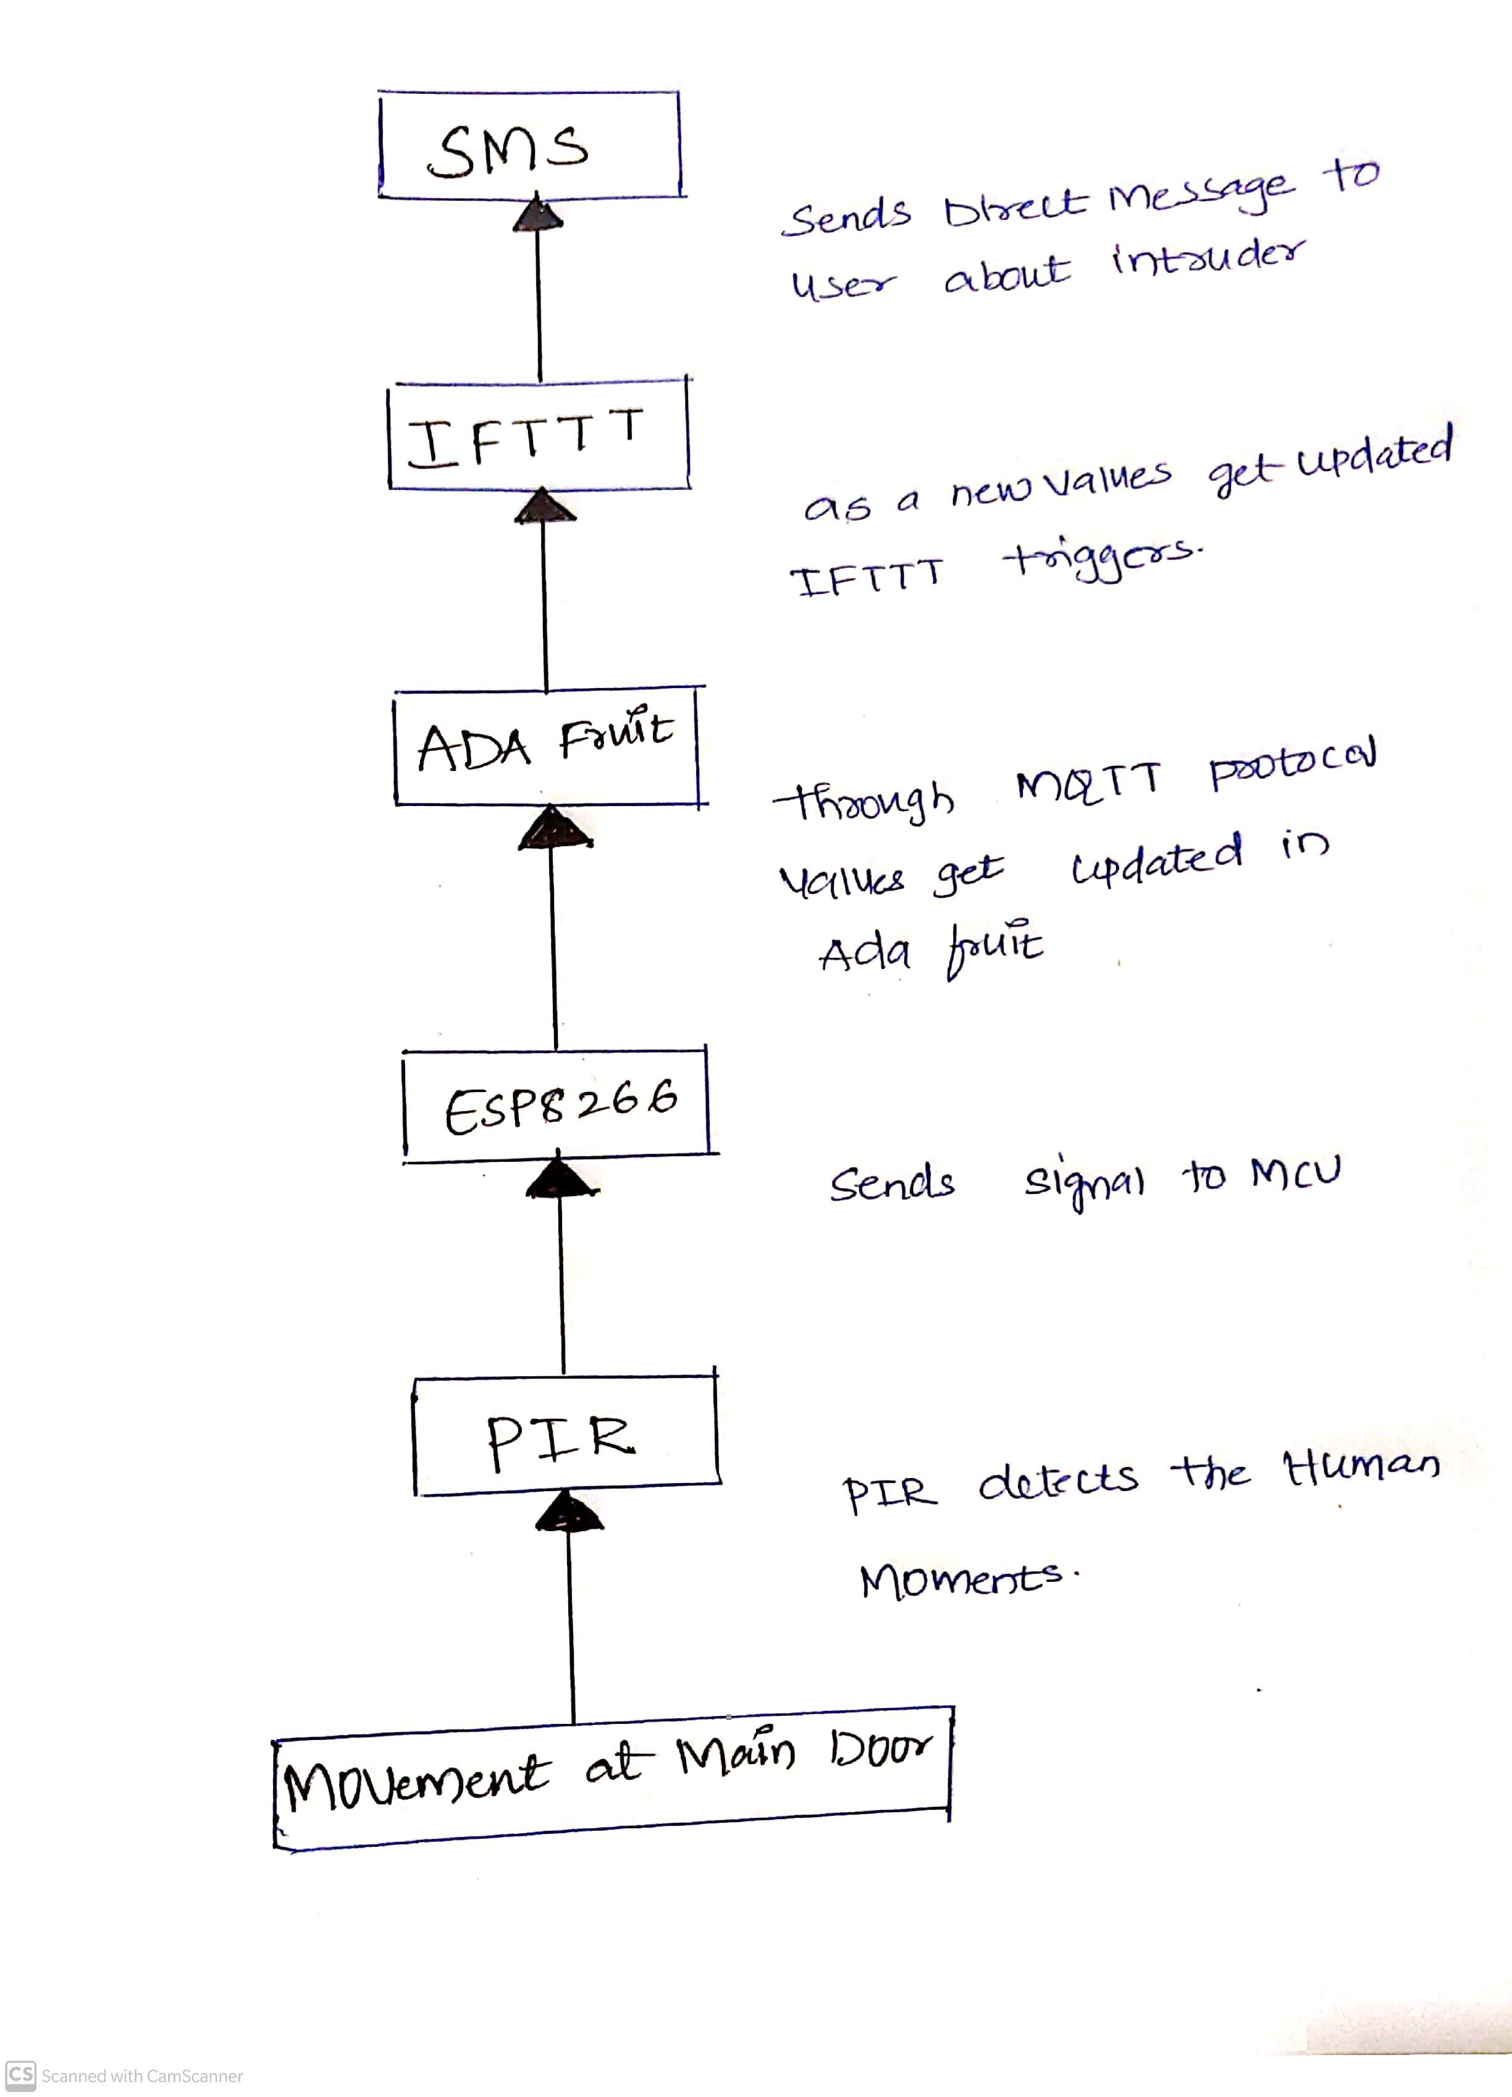

PIR detects the human momentsand it sends the signal to MCU through MQTT protocal values get updated in ADAfruit . As a new values get updated IFTTT triggers and sends the direct message to user about intruder thorugh sms

APPLICATIONS AND USES:

* An inexpensive security system for every home.
* It is also used in industrial use.
* Improves monitoring.
* Minimizes human effort.
* Makes you self-depended.